REPLY FORM

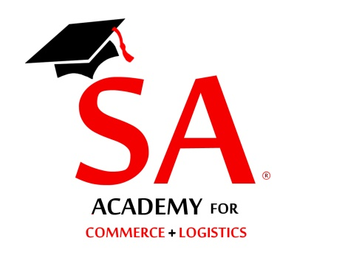
Training Programme on Customs Export Import Procedures
Please send all applications preferably by email
Attn: Shippers’ Academy Colombo (Pvt) Ltd

ATTN: Secretary
Email: enquiries@shippersacademy.lk
Tele: 077-3820703/0113560844

Fax: 0112874065/0112472535

Please reply on or before 21st May 2018

Shippers’ Academy Colombo
105, Hunupitiya Lake Road
Colombo 02

Reference your circular dated 9th May 2018; we have the pleasure in nominating the following representatives to attend the workshop on Customs Export Import Procedures on 23rd May 2018 at the Distance Learning Centre, SLIDA, Colombo 7

NAME OF COMPANY :…………………………………………………………………………….

ADDRESS :……………………………………………………………………………..

TEL NOS :……………………………MOBILE:……………………………………..

FAX NO. :……………………E-MAIL………….……………………………………

NAME DESIGNATION Mobile E-mail

1)……………………………………………. ………………… …………………….. …………………..

2)……………………………………………….. ………………… ……………………. …………………..

3)……………………………………………….. ………………… ……………………. …………………..

4)……………………………………………….. ………………… ……………………. …………………..

5)……………………………………………….. ………………… ……………………. …………………..

Attached please find Cheque No:……………/ Bank ….….for Rs………………being participation fee at the above forum.

Cheques should be drawn in favour of “Shippers’ Academy Colombo (Pvt) Ltd” (Rs. 8,000/- per participant, including lunch)

Name…………………………………….. Signature………………………..

Designation:……….…………………… Date:…………………………….

